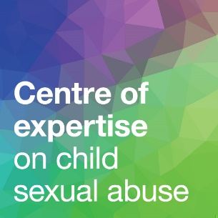
School safety
plan template
September 2022
This template accompanies, and should be used alongside,
our guide to Safety Planning in Education.
It is designed for use by a school’s Designated Safeguarding Lead during and after safety planning meetings for children involved in incidents of harmful sexual behaviour.
Use a separate copy of the template to record actions for each child. Please adjust the number of rows overleaf as appropriate.
Safety plan for: [name(s) of child(ren)]
Completed by: |  | Date:
Attendees:
[those who have contributed to the plan]

Identified concern  or risk | Action(s) required | Responsibility | Date for review | Additional information [e.g. rationale for action]
Contact between the children
Other arrangements in school
Other arrangements outside school

